P.O. Box 163 | 412 Roncesvalles Avenue | Toronto, ON. M6R 2N2 CANADA
Phone: +1-416-580-3040 | Fax: +1-416-588-3238 | www.pinwheelmusic.com
Publicity: Johan Hultqvist | johan@pinwheelmusic.com

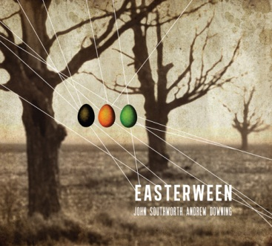
A 500-year-old magician. A ruthless, multinational egg corporation. A love story between a Hasidic girl and an Amish boy. A band of sauciers and dumpling bakers. An egg-hunt of cosmic proportions to save us all from eternal winter.
Welcome to the world of Easterween.

With a career spanning 16 years and 8 albums, John Southworth has produced some of the most unique song-writing ever committed to record. On his 9th outing, Canada’s most inimitable imaginator has upped the ante by enlisting the arranging genius of JUNO-winning composer-bassist-cellist Andrew Downing.

The result is a vertiginous, cinematic journey in the spirit of Bertolt Brecht and Kurt Weill. A 21st century metaphysical fertility tale set to 19th century surreal street-cabaret songs. Imagine pop music arranged by Igor Stravinsky, with lyrics dictated by David Lynch on a vision quest. If Easterween sounds like a movie waiting to be made, it’s for good reason.

A film buff who directs his own videos, Southworth wrote a 120-page screenplay for Easterween from which he distilled a dozen songs charting a hallucinatory journey and metaphysical rite of passage. Lacking the $ 10 million it would cost to make the film he settled for the next best thing: a one-of-a-kind album with arrangements by Andrew Downing. Having written a score for the legendary 1920 silent film The Cabinet of Dr. Caligari - a dark and dreamlike tale widely regarded as the first ever horror movie – Downing was the perfect collaborator.
Part Edgar Allan Poe and part Rite of Spring, Easterween tells the magic-realist tale of a mythological egg-hunt set during an eternal winter. Robert Kirk is a 500-year-old magician who contacts the Faerie kingdom to help him end the icy spell. The Faerie King and Queen choose a 16-year-old Amish boy named Johann and a 16-year-old Hasidic girl named Sylvia who, despite their different backgrounds, come together in a powerful union. Their all-important task is to find three eggs hidden throughout Pennsylvania. While looking for the eggs they are hunted by sinister Noombs and the heads of GMO companies. If the teens find the eggs the corporate monopoly on the seed kingdom will be over. But in order for spring to happen Johann and Sylvia also have to return the eggs to Pennsylvania’s Mountain of the Egg – all by the eve of Easterween!

www.easterween.ca
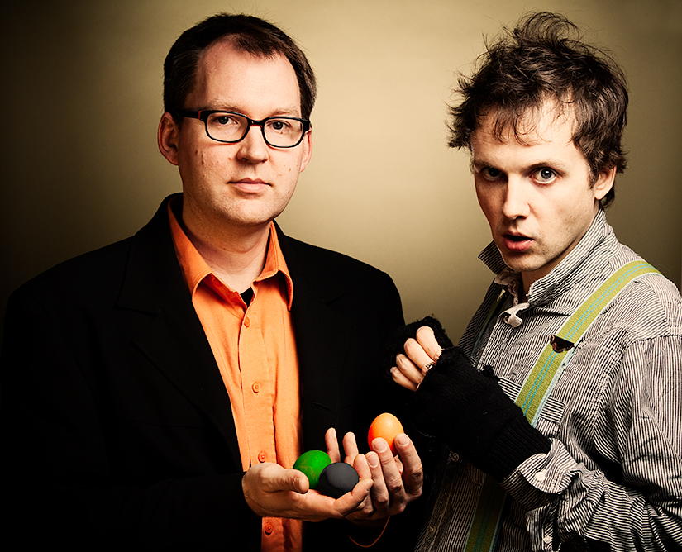
Artist: John Southworth & Andrew Downing
Album: Easterween
Release date: April 3, 2012
Label: Sud de Valeur

Easterween features
John Southworth - voice
Andrew Downing - cello
Peter Lutek - clarinet
Kevin Turcotte - trumpet
William Carn - trombone
Aleksandar Gajic - violin
David Occhipinti - guitar
Joe Phillips - double bass

April 4 & 5, 2012: Toronto, ON – Lower Ossington Theatre (100A Ossington Ave.) - $10/$15

About Andrew Downing
Toronto-based double bass player, cellist, composer and bandleader Andrew Downing plays primarily in the creative jazz scene in Canada, but also performs classical chamber music, improvised music, folk and roots music, and world music. He has written pieces for Ensemble Meduse, Toca Loca, Runcible Spoon, The Prince George Symphony and The Urban Arts Brass Ensemble and has written arrangements for Patricia O'Callaghan, The Gryphon Trio and The Art of Time Ensemble. Upcoming projects include a composition for Orchestra London with banjo player Jayme Stone. Andrew leads his own chamber jazz ensemble, has seven albums as a bandleader, and is also a member of the David Occhipinti Quartet and the Lina Allemano Four. He has won Juno, SOCAN, Grand Prix de Jazz (Montreal Jazz Festival), and two West Coast Music Awards. Andrew is on faculty at the University of Toronto and has taught at Wilfred Laurier University, the Banff Centre's Jazz Workshop and the Creative Music Workshop in Halifax.

About John Southworth
“Is to music what Guy Maddin is to film“
-Rich Terfry, CBC Radio 2
“Wonderful, sylvan, sprightly, uber-bolangaire, peculiar and smart.” -Guy Maddin

John Southworth is one of Canada’s most distinctive and iconoclastic music artists, respected for forging ahead with his own unique brand of music-making, while garnering high praise for his inimitable contribution. His songs have been covered by great Canadian artists like Sarah Slean, Martin Tielli (Rheostatics), Mary Margaret O'Hara, and Veda Hille. He has also written songs for artists as diverse as Hawksley Workman, Buck 65, and Jully Black. John has authored a children’s book in the realm of Edward Gory and Lewis Carroll, with illustrations by New York artist David Ouimet, to be published in fall 2012. John is also a regular collaborator with Toronto’s Art of Time Ensemble.

